

### SAVITRIBAIPHULEPUNEUNIVERSITY

**APRELIMINARYPROJECTREPORTON**

# “DrowsinessDetectionandAlertSystemUsingMachineLearningApproach”

SUBMITTEDTOTHESAVITRIBAIPHULEPUNEUNIVERSITY,PUNEINTHEPARTIALFULFILLMENTOFTHEREQUIREMENTSFORTHEAWARDOFTHEDEGREE

OF

# BACHELOROFENGINEERING(COMPUTERENGINEERING)

BY

### SATANSHU SATISH AGLAWE 72142330C

**ADITYA DILIP AGRAWAL 7214233M**

### ANKUR SURESH SURWASE 72142346K

**NIKHIL KASHINATH BAVA 72142371L**

**SHUBHAM MAHADEVAPPA MAHAGAONKAR 72142607H**

*Under the guidance of*

### Prof.V. V. WAYKULE



No.1,KennedyRoad,NearRTOOfficeSangamwadi,Shivajinagar,Pune-411001



# CERTIFICATE

This is to certify that the project report entitled

**“DrowsinessDetectionandAlertSystemUsingMachineLearningApproach”**

Submittedby

### SATANSHU SATISH AGLAWE 72142330C

**ADITYA DILIP AGRAWAL 7214233M**

### ANKUR SURESH SURWASE 72142346K

**NIKHIL KASHINATH BAVA 72142371L**

**SHUBHAM MAHADEVAPPA MAHAGAONKAR 72142607H**

is a bonafide work carried out by them under the supervision of Prof. VidyaV. Waykule and it isapproved for the partial fulfillment of the requirement of Savitribai Phule Pune University Pune for theawardofthedegreeofBachelorof Engineering (Computer Engineering). This project work has notbeen earlier submitted to any other Institute or University for the award of any degree or diploma.

**Prof. V. V. WAYKULE** **Dr.S.V.Athawale Prof.V.V.Navale**

**Prof. S. R. NALAMWAR**

Project Guide H.O.D Computer Engineering Project Coordinator

**Dr.DSBormane**

Internal Examiner External Examiner Principal,

AISSMSCOE,Pune

Date

Place: Pune

PROJECTAPPROVALSHEETA

### Project

on

**“DrowsinessDetectionandAlertSystemUsingMachineLearningApproach”**

Is successfully completed by

### SATANSHU SATISH AGLAWE 72142330C

**ADITYA DILIP AGRAWAL 7214233M**

### ANKUR SURESH SURWASE 72142346K

**NIKHIL KASHINATH BAVA 72142371L**

**SHUBHAM MAHADEVAPPA MAHAGAONKAR 72142607H**

at

### Department of Computer EngineeringAISSMS College of Engineering, PuneSavitribai Phule Pune University

**2022-2023**

### Prof.V. V. WAYKULE Dr.SVAthawale

Project Guide HOD

Department of Computer Engineering



# ACKNOWLEDGEMENT

We would like to extend my sincere gratitude and thanks to my guide Prof. V. V.Waykule for herinvaluable guidance and for giving us useful inputs and encouragement time and again, which inspiredus to work harder. Due to her forethought, appreciation of the work involved and continuous impartingof useful tips, this report has been successfully completed.

We are extremely grateful to Dr. S. V. Athawale, Head of the Department of Computer Engineering, forhis encouragement during the course of the project work.

We also extend our heartfelt gratitude to the entirestaff of the Computer Engineering Department fortheir cooperation and support.

We are grateful to Dr. D S Bormane, Principal, AISSMS College of Engineering for his encouragementduring the course of the project work.

We also take this opportunity to thank all our classmates, friends and all those who have directly orindirectly provided their overwhelming support during our project work and the development of thisreport.

### SATANSHU SATISH AGLAWE 72142330C

**ADITYA DILIP AGRAWAL 7214233M**

### ANKUR SURESH SURWASE 72142346K

**NIKHIL KASHINATH BAVA 72142371L**

**SHUBHAM MAHADEVAPPA MAHAGAONKAR 72142607H**



# ABSTRACT

Many of the accidents occur due to drowsiness of drivers. It is one of the critical causes of roadways accidents now-a-days. Latest statistics say that many of the accidents were caused because of drowsiness of drivers. Vehicle accidents due to drowsiness in drivers are causing death to thousands of lives. More than 30% of accidents occur due to drowsiness. For the prevention of this, a system is required which detects drowsiness and alerts the driver which saves the life. In this project, we present a scheme for driver drowsiness detection based on visual information and Machine Learning. In this, the driver is continuously monitored through a webcam. This system is used to locate, track, and analyze both the drivers face and eyes, a scientifically supported measure of drowsiness associated with slow eye closure. The model extracts the driver's face and predicts the blinking of the eye from the eye region. If the blinking rate is high then the system alerts the driver with a sound.

# LISTOFFIGURES

|  |  |  |
| --- | --- | --- |
| Sr.No | Title | PageNumber |
| 2.1 | EEGDataCollecting | 15 |
| 2.2 | ExamplesofEyelidMovement | 15 |
| 2.3 | ExamplesofPersoninNormalandYawningCondition | 16 |
| 6.1 | DataFlowDiagram | 21 |
| 6.2 | Flowchart | 22 |
| 6.3 | UseCaseDiagram | 23 |
| 6.4 | ClassDiagram | 24 |
| 6.5 | ActivityDiagram | 25 |
| 7.1 | ConvolutionalNeuralNetworkArchitecture | 27 |
| 7.2 | HAARCascade | 30 |
| 7.3 | ReLU | 33 |
| 7.4 | Dropout | 36 |
| 8.1 | GUIScreen | 42 |
| 8.2 | OperationalWindow | 43 |
| 8.3 | InputVideoScreen1 | 44 |
| 8.4 | InputVideoScreen2 | 44 |
| 8.5 | InputVideoScreen3 | 45 |
| 8.6 | OutputScreen1 | 45 |
| 8.7 | OutputScreen2 | 46 |
| 9.1 | TerminalOutputScreen1 | 49 |
| 9.2 | TerminalOutputScreen2 | 50 |

**LISTOFTABLES**

|  |  |  |
| --- | --- | --- |
| No. | Title | Page Number |
| 3.1 | HardwareRequirement | 17 |

# CONTENTS

### ACKNOWLEDGEMENTABSTRACT

**LIST OF FIGURESLIST OF TABLESCHAPTER 1**

### INTRODUCTION

**ivvi**

### vii11

* 1. ProjectTitle
  2. Introduction to Project
  3. Deep Learning
  4. TechnicalKeywords
  5. Domain of Project
  6. Problem Statement
  7. Dataset
  8. Scope
  9. Internal Guide

CHAPTER 2 14

LITERATURESURVEY

CHAPTER 3

SOFTWAREANDHARDWAREREQUIREMENTS 17

* 1. Software Requirement
  2. Hardware Requirement

CHAPTER 4

GOALS AND OBJECTIVES 18

* 1. Goal
  2. Objectives

### CHAPTER5

### METHODOLOGY 19

* 1. Data Collection
  2. Data Preparation
  3. Loading the Data
  4. Data Mining
  5. ModelTraining
  6. TestingtheModel

### CHAPTER 6

**UML DIAGRAM 21**

* 1. Data flow Diagram
  2. Flowchart
  3. Use case Diagram
  4. Class Diagram
  5. Activity Diagram

### CHAPTER 7

**ALGORITHM & SYSTEM ARCHITECTURE 26**

* 1. Convolution Neural Network
  2. HAAR Cascade
  3. Working
     1. Activation functions
        1. ReLU
        2. Sigmoid
        3. Softmax
  4. Dense Layers

7.4.1 Keras Dense Layer Hyper Parameter

* 1. Dropout
  2. MaxPooling 2D
  3. Batch Normalization Layer
  4. Flatten Layer
  5. Purpose of using CNN

### CHAPTER 8

**IMPLEMENTATIONANDEXECUTION 41**

* 1. CNN
  2. GUI
  3. Input
  4. Expected Outcomes
  5. Project Estimate
     1. Reconciled Estimates
     2. Project Resources
  6. Risk Management
     1. Risk Identification
  7. Project Schedule
     1. ProjectTaskSet
  8. TeamOrganization
     1. TeamStructure
     2. Management Reporting and Communication

### CHAPTER 9

**RESULTS 49**

* 1. Screenshots of Output
  2. Conclusion
  3. Future Scope of the Project
  4. Advantages
  5. Disadvantages
  6. Applications

### REFERENCES 54

**REPORTDOCUMENTATION 55**

# CHAPTER 1INTRODUCTION

## ProjectTitle

Drowsiness Detection and Alert System for drivers using Machine Learning Approach

## Introduction

Increasing accidents due to unconsciousness or due to a driver’s diminished vigilance is aserious contribution to overall accidents in the world. However major accidents in the worldare related to driver fatigue or drowsiness. Car accidents associated with driver fatigue aremore likely to be serious, leading to serious injuries and deaths.

It is estimated that 40% of all traffic accidents have been caused by drowsiness. It wasdemonstrated that driving performance deteriorates with increased drowsiness with resultingcrashes constituting more than 20% of all vehicle accidents. The performance of the driveralso deteriorates with drowsiness.

Every fraction of seconds drowsiness can turn into dangerous and life- threatening accidentsthatmayleadtodeath also. To prevent this type of incidents, it is required to monitordriver’s alertness continuously and when it detects drowsiness, the driver should be alerted.Through this we can reduce the significant number of accidents and can save the lives ofpeople.

## MachineLearning

Machinelearningisabranchofartificial intelligence (AI) and computer science whichfocuses on the use of data and algorithms to imitate the way that humans learn, graduallyimprovingits accuracy.

Over the last couple of decades, the technological advances in storage and processing powerhaveenabledsomeinnovativeproductsbasedonmachinelearning,suchasNetflix’srecommendation engine and self-driving cars.

Machine learning is an important component of the growing field of data science. Throughthe use of statistical methods, algorithms are trained to make classifications or predictions,andtouncoverkeyinsightsindataminingprojects. These insights subsequently drivedecision making within applications and businesses, ideally impacting key growth metrics.Asbigdatacontinuestoexpandandgrow,themarketdemandfor data scientists willincrease. They will be required to help identify the most relevant business questions and thedatatoanswerthem.Machinelearningalgorithmsare typically created using frameworksthatacceleratesolutiondevelopment,such asTensorFlowandPyTorch.

## TechnicalKeywords

* + - Machine Learning
    - Convolutional Neural Network
    - HAAR Cascade
    - Image recognition
    - Face Detection

## DomainoftheProject

MachineLearning,Python,OpenCV,Facerecognition

## ProblemStatement:

DesignandimplementamodelfordetectingdrowsinessandAlertSystemfordriversusing ML Approach

## Dataset

The dataset used for this model is created by writing a script that captures eyes from acamera and stores them in our local disk. We separated them into their respective labels‘Open’ or ‘Closed’. The data was manually cleaned by removing the unwanted imageswhich were not necessary for building the model. The data comprises images of people’seyes under different lighting conditions. After training the model on our dataset, we haveattached the final weights and model architecture file “models/cnnCat2.h5”. Now, we canusethis model to classifyif a person’s eye isopen or closed.

## Scope:

The model could be used to detect drowsiness in drivers, machine operators, or individualsinsafety-criticalprofessions.Thereal-timedataiscollectedfromtheweb-camofthehardware attached to it. The data is in the form of Facial features like eye movements, eyeblinking and eye aspect Ratio. To classify these features and analyze the collected data, wehaveusedConvolutionalNeuralNetworkAlgorithmtodetectthesignsofdrowsiness.Inthebackend,HAARCascadeClassifierisusedtotrainthemodel.Asandwhenthedrowsiness detection system meets the desired performance criteria, it can be deployed inthe target environment. Regular maintenance and updates will be required to ensure thesystemremains effective and compatible with changing requirements.

## InternalGuide:

* + - **Prof.V. V. WAYKULE**

# CHAPTER 2LITERATURESURVEY

Therearedifferentapproachestoidentifythedrowsinessstateofthedriver.Theseapproaches can be categorized into the following three main categories:

1. Behavioral parameters-based techniques: Measuring the driver’s fatigue withoutusing non-invasive instruments comes under this category. Analyzing the behaviorof the driver based on his/her eye closure ratio, blink frequency, yawning, positionof the head and facial expressions. The current parameter used in this system is theeye-closureratio of the driver.
2. Vehicular parameters-based techniques: Measuring the fatigue nature of the driverthroughvehicledrivingpatternscomesunderthiscategory.Theseparametersinclude lane changing patterns, steering wheel angle, steering wheel grip force,vehicle speed variability and many more.
3. Physiological parameters-based techniques: Measuring the drowsiness of the driverbasedonthephysicalconditionsofthedriverfallsunderthis category. Suchparameters may be respiration rate, heart-beat rate, body temperature and manymore.

Inthissection, we have discussed various methodologies that have been proposed byresearchers for drowsiness detection and blink detection during the recent years.

1. Drowsiness and Fatigue

Drowsiness is where a person is in the middle of an awake and sleepy state.Thissituationleadsthedrivertonotgivingfullattentiontotheirdriving.Therefore, the vehicle can no longer be controlled due to the driver being in asemi-consciousstate.Accordingtoresearchmentalfatigueisafactorofdrowsiness and it causes the person who experiences drowsiness to not be able toperform because it decreases the efficiency of thebrain to respond towards suddenevents.

1. Electroencephalography (EEG) for Drowsiness Detection

Electroencephalography(EEG)isamethodthatmeasuresthebrain'selectrical activity. As shown in Figure 3, it can be used to measure the heartbeat,eye blink and even major physical movement such as head movement. It can beusedonhumansoranimalsassubjectstoget brain activity. It uses a specialhardware that places sensors around the top of the head area to sense any electricalbrainactivity.

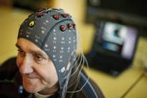

**Figure2.1:**EEGDataCollecting

1. Drowsiness detection using face detection system

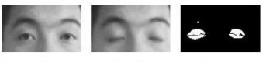Drowsiness can be detected by using face area detection. The methods todetect drowsiness within face area vary due to drowsiness signs are more visibleand clearer to be detected at face area. From the face area, we can detect the eye'slocation.Fromeyesdetection,wecansaythattherearefourtypes of eyelidmovement that can be used for drowsiness detection. They are completely open,completely close, and in the middle where the eyes are from open to close and viceversa. Figure 2 is an example of the image taken for detecting eyelid movement.

* 1. Open eye b) Close eye c) Processed closed eye

**Figure2.2:**ExamplesofEyelidMovement

The algorithm processes the images captured in a gray-scale method; wherethe color from the images is then transformed into black and white. Working withblackandwhiteimagesiseasierbecauseonlytwoparametershavetobemeasured. Edge detection is performed to detect the edges of eyes so that the valueofeyelidareacanbecalculated.Theproblemoccurringwiththismethodisthatthe size of the eye might vary from one person to another. Someone may havesmall eyes and look like they are sleepy but some are not. Other than that, if theperson is wearing glasses, there is an obstacle to detect eye regions. The imagesthat are captured must be in a certain range from the camera because when thedistance is far fromthe camera, the images are blurred.

1. PERCLOS

Drowsiness can be captured by detecting the eye blinks and percentage ofeye closure (PERCLOS). For eye blink detection, propose a method which learnsthe pattern of durationof eyelid closed. This method measures the time for aperson to close their eyes and if they are closed longer than the normal eye blinktime, it is possible that theperson is falling asleep’.

ThePERCLOSmethodproposesthatdrowsinessismeasuredbycalculating the percentage of theeyelid ‘drops’. Sets of eye open and eye closedhavebeenstoredinthesoftwarelibrarytobeusedasaparametertodifferentiate

whether the eyes are fully open or fully closed. For eyelids todroop, it happens inmuch slower time as the person is slowly falling asleep. Hence, thetransition ofthedriver’sdrowsinesscanberecorded.Thus,PERCLOSmethodputsaproportionalvalue where when the eye is 80% closed, which it is nearly to fullyclose,it is assumed thatthe driver isdrowsy.

This method is not convenient to be used in real-time driving as it needs tofixthethresholdvalueofeye opening for the PERCLOS method to performaccurately.BothmethodstodetectdrowsinessusingeyeblinkpatternsandPERCLOS have the same problem where the camera needs to beplaced at aspecificangleinordertogetagoodimageofvideowithnodisturbanceofeyebrowand shadow that cover the eyes.

1. YawningDetectionMethod

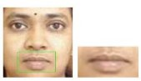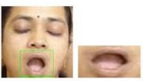Drowsinessofapersoncanbeobservedbylookingattheirfaceandbehavior.Amethodis proposed where drowsiness can be detected by mouthpositioning and theimages were processed by using a cascade of classifiers thathas been proposed by Viola-Jones forfaces. The images were compared with theset of images data for mouth and yawning. Somepeople will close their mouthwith their hand while yawning. It is an obstacle to get good images if a person isclosing their mouth while yawning but yawning is definitely a sign of a personhaving drowsiness and fatigue. Fig 3 demonstrates the face of human when inNormaland Yawning condition

**Figure2.3:**ExamplesofPersoninNormalandYawningCondition

# CHAPTER3

# SOFTWAREANDHARDWAREREQUIREMENTS

## SoftwareRequirement

* + Programming Language: Python 3.x +
  + IDE: VS Code
  + Libraries:
    - OS
    - OpenCV
    - Keras
    - Pygame
    - Pandas
    - TensorFlow

## HardwareRequirement

|  |  |  |  |
| --- | --- | --- | --- |
| Sr.No | Parameter | Minimum Requirement | Justification |
| 1 | CPU Speed | 2 GHz | Minimum CPU speed required |
| 2 | RAM | 4 GB | Minimum RAM required |
| 3 | Webcam | 6 MegaPixel | Minimum resolutionrequired tocapture human face |

**Table3.1:**HardwareRequirements

# CHAPTER 4GOALSANDOBJECTIVES

## Goal:

ThegoalofthisprojectistodetectthedrowsyconditionofthedriverusingMLapproach and alert the driver through alarm and sound.

## Objectives:

Todetectthedrowsinessconditionofthedriverwehavedefinedfourobjectivesforthisproject.

* + - Todetecttheparametersthatdeterminethelevelofdrowsinessofthedriver.
    - ToanalyzeandpredictthedrowsyconditionofthedriverusingMLtechniques.
    - Toinvestigatethephysicalchangesoffatigueanddrowsiness.
    - TodevelopasystemthatusesEyeAspectRatio(EAR)asawaytodetectfatigueanddrowsinessand alert the driver.
  1. **DataCollection**

# CHAPTER 5METHODOLOGY

Datacollectionisaprocessofsystematicallygatheringandmeasuringinformation from a variety of sources to get a complete and accurate scenario of theexpected results.

## DataPreparation

Inthisstep,wehavetodownloadandconvertthedatasettobesuitedforextraction purposes. Data preparation is a process of getting data ready to use by cleaningand transforming raw data prior to processing and analysis. It is an important step prior toprocessing and often involves reformatting data, dealing with the missing value, makingcorrections to data and then combining data sets to enrich data.

## LoadingtheData

In this process, the dataset is loaded in Python which requires extraction of thevisualfeatures, for instance obtaining different features such as the eye closure, facedetected etc from the video inputs.

## DataMining

In this step, the features are extracted from the raw image input data for modeltraining.Dataminingisaprocessusedbycompaniestoturnrawdataintousefulinformation at a decreased cost.

## ModelTraining

After the completion of all the above steps, we have to train the extracted featureson the model.

## TestingtheModel

Thisisthefinalstepformeasuringhowgoodandaccuratethemodelistrained.

Theaccuracyiscalculatedtodeterminethemodelefficiency.

# CHAPTER 6SYSTEMDESIGN

## DataflowDiagram

This diagramisagraphicalrepresentationofthe―flowofdatathroughaninformation system, modeling its process aspects. A Data flow diagram is often used as apreliminary step to create an overview of the system withoutgoing into great detail,which can later be elaborated.

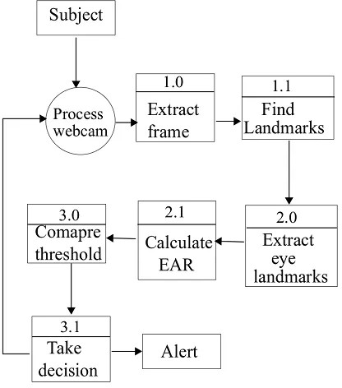

**Figure6.1:**DataFlowDiagram

## Flowchart

A flowchart is a type of diagram that represents a workflow or process. Aflowchart can also be defined as a diagrammatic representation of an algorithm, a step-by-step approachto solving a task. The flowchart shows the steps as boxes of various kinds, and their order by connectingtheboxeswitharrows.

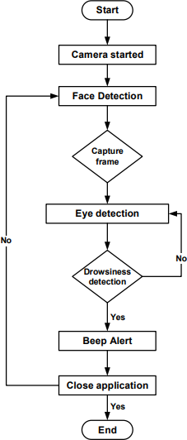

**Figure6.2:**Flowchart

## UsecaseDiagram

A use case diagram is a way to summarize details of a system and the users withinthatsystem.Usecasediagramisagraphicdepictionoftheinteractionsamong theelements of a system. Use cases will specify the expected behavior, and the exact methodof making it happen. Use cases once specified can be denoted both textual and visualrepresentation.

Use case diagrams are used to specify:

Requirements (external), required usages of a system under design or analysis - tocapture what the system is supposed to do.The functionality offered by a subject – whatthe system can do. Requirements the specified subject poses on its environment - bydefining how the environment should interact with the subject so that it will be able toperform its services.

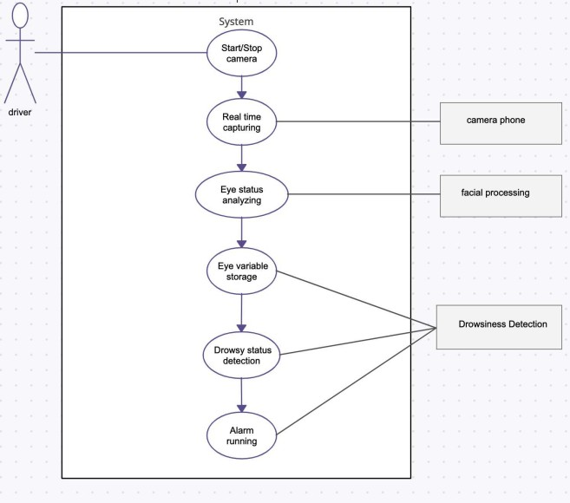

**Figure6.3:**UsecaseDiagram

## ClassDiagram:

Class diagrams are the blueprints of your system. You can use class diagrams tomodeltheobjectsthatmakeup the system, to display the relationships between theobjects, and to describe what those objects do and the services that they provide. Classdiagrams are useful in many stages of the system design.

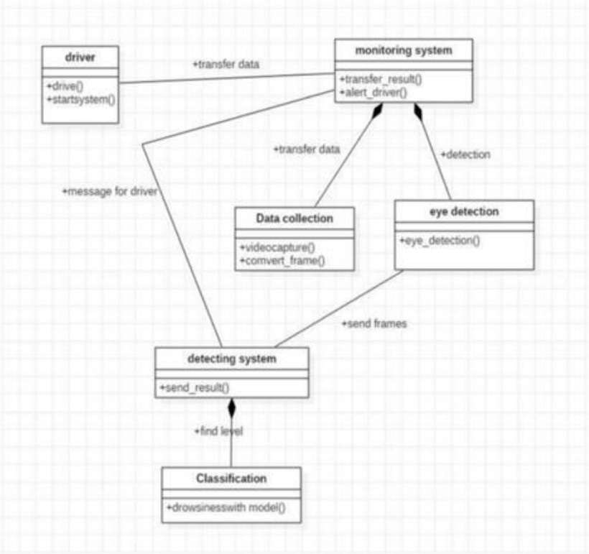

**Figure6.4:**ClassDiagram

## ActivityDiagram

An activity diagram visually presents a series of actions or flow of control in asystemsimilartoaflowchartoradataflowdiagram.ActivitydiagramisanotherimportantdiagraminUMLtodescribedynamicaspectsofthesystem.Activitydiagramis basically a flowchart to represent the flow from one activity to another activity. Theactivity can be described as in operation of the system. The control flow is drawn fromoneoperation to another.

**Figure6.5.:**ActivityDiagram

# CHAPTER7

**ALGORITHM&SYSTEMARCHITECTURE**

## ConvolutionNeuralNetwork(CNN)

CNN is very useful as it minimizes human effort by automatically detecting thefeatures. For example, for apples and mangoes, it would automatically detect the distinctfeatures of each class on its own.CNNs are a class of Deep Neural Networks that canrecognize and classify particular features from images and are widely used for analyzingvisualimages.Theirapplicationsrangefromimageandvideorecognition,imageclassification, medical image analysis, computer vision and natural language processing.

CNNhashighaccuracy,andbecauseofthesame,itisusefulinimage

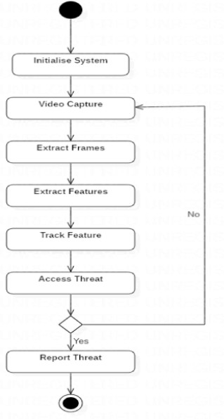recognition.Imagerecognitionhasawiderangeofusesinvariousindustriessuchasmedicalimageanalysis, phone,

security,recommendationsystems,etc.

Theterm‘Convolution”inCNNdenotesthemathematicalfunctionofconvolutionwhichisaspecialkindoflinearoperationwhereintwofunctionsaremultiplied to produce a third function which expresses how the shape of one function ismodified by the other. In simple terms, two images which can be represented as matricesare multiplied to give an output that is used to extract features from the image.

### BasicArchitecture:

A convolution tool that separates and identifies the various features of the imagefor analysis in a process called Feature Extraction. The network of feature extractionconsists of many pairs of convolutional or pooling layers. A fully connected layer thatutilizes the output from the convolution process and predicts the class of the image basedonthe features extracted in previous stages. This CNN model of feature extraction aimstoreducethenumberoffeatures present in a dataset. It creates new features whichsummarizes the existing features contained in an original set of features. There are manyCNN layers as shown in the CNN architecture diagram.

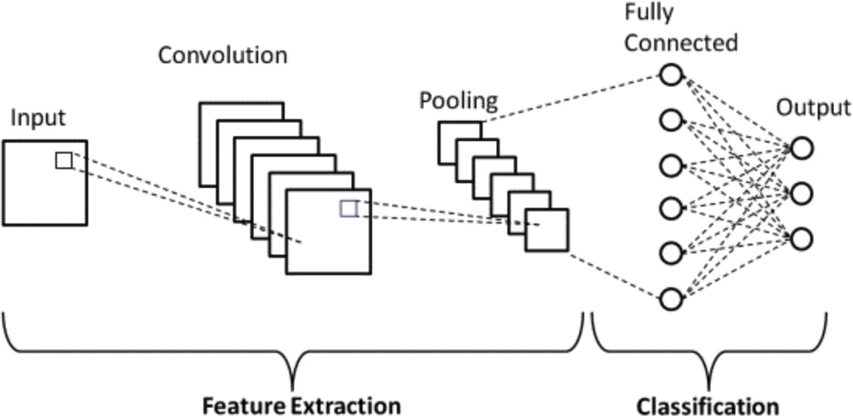

**Figure7.1:**ConvolutionalNeuralNetworkArchitecture

### Convolutional Layer:

This layer is the first layer that is used to extract the various features from theinputimages.Inthislayer,themathematicaloperationofconvolutionisperformedbetweentheinputimageandafilterofaparticularsizeMxM.Byslidingthefilterover

the input image, the dot product is taken between the filter and the parts of the inputimage with respect to the size of the filter (MxM).

The output is termed as the Feature map which gives us information about theimage such as the corners and edges. Later, this feature map is fed to other layers to learnseveral other features of the input image.

TheconvolutionlayerinCNNpassestheresulttothenextlayeronceapplyingthe convolution operation in the input. Convolutional layers in CNN benefit a lot as theyensure the spatial relationship between the pixels is intact.

### Pooling Layer:

In most cases, a Convolutional Layer is followed by a Pooling Layer. The primaryaimofthis layer is to decrease the size of the convolved feature map to reduce thecomputational costs. This is performed by decreasing the connections between layers andindependently operates on each feature map. Depending upon the method used, there areseveral types of Pooling operations. It basically summarizes the features generated by aconvolutionlayer.

InMaxPooling,thelargestelementistakenfromthefeature map. AveragePooling calculates the average of the elements in a predefined size Image section. Thetotal sum of the elements in the predefined section is computed in Sum Pooling. ThePooling Layer usually serves as a bridge between the Convolutional Layer and the FCLayer.

This CNN model generalizes the features extracted by the convolution layer, andhelps the networks to recognise the features independently. With the help of this, thecomputations are also reduced in a network.

### Fully Connected Layer

The Fully Connected (FC) layer consists of the weights and biases along with theneurons and is used to connect the neurons between two different layers. These layers areusuallyplacedbeforetheoutputlayerandformthelastfewlayersofaCNNArchitecture.

Inthis,theinputimagefromthepreviouslayersareflattenedandfedtotheFC

layer. The flattened vector then undergoes few more FC layers where the mathematicalfunctions operations usually take place. In this stage, the classification process begins totake place. The reason two layers are connected is that two fully connected layers willperformbetterthanasingleconnectedlayer.TheselayersinCNNreducehumansupervision.

### Dropout:

Usually,whenallthefeaturesareconnectedtotheFClayer,itcancauseoverfitting in the training dataset. Overfitting occurs when a particular model works sowellonthetrainingdatacausinga negative impact in the model’s performance whenused on new data.

To overcome this problem, a dropout layer is utilized wherein a few neurons aredropped from the neural network during the training process resulting in reduced size ofthe model. On passing a dropout of 0.3, 30% of the nodes are dropped out randomly fromthe neural network.

Dropout results in improving the performance of a machine learning model as itprevents overfitting by making the network simpler. It drops neurons from the neuralnetworks during training.

### Activation Functions:

Finally, one of the most important parameters of the CNN model is the activationfunction. They are used to learn and approximate any kind of continuous and complexrelationshipbetweenvariablesofthenetwork.Insimplewords,itdecideswhichinformationofthemodelshouldfireintheforwarddirectionandwhichones should notat the end of the network.

It adds non-linearity to the network. There are several commonly used activationfunctions such as the ReLU, Softmax, tanH and the Sigmoid functions. Each of thesefunctions have a specific usage. For a binary classification CNN model, sigmoid andsoftmax functions are preferred and for a multi-class classification, generally softmax isused. In simple terms, activation functions in a CNN model determine whether a neuronshouldbeactivatedornot.Itdecideswhethertheinputtothe workisimportantornotto

predict using mathematical operations.

## HAARCASCADE

Haarcascadeisanalgorithmthatcandetect objects in images, irrespective oftheirscaleinimageandlocation.Thisalgorithmisnotsocomplexandcanruninreal-time. We can train a haar-cascade detector to detect various objects like cars, bikes,buildings, fruits, etc.Haar cascade uses the cascading window, and it tries to computefeatures in every window and classify whether it could be an object.

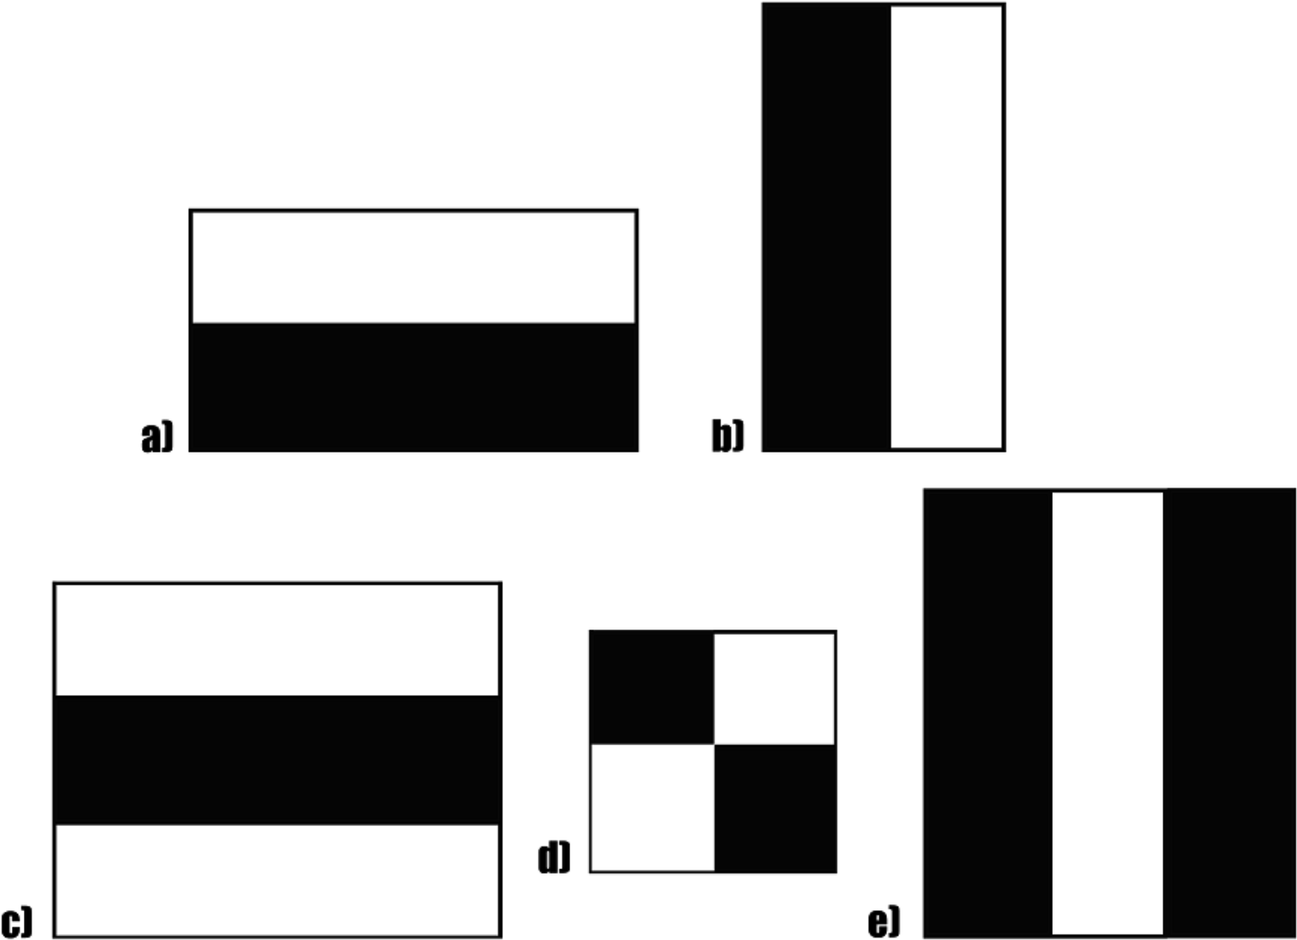

**Figure7.2**HAARCascade

Sample haar features traverse window-sized across the picture to compute andmatchfeatures.Haarcascadeworksasaclassifier.Itclassifiespositivedatapoints→that

arepartofourdetectedobjectandnegativedatapoints→thatdon’tcontainourobject.Haar cascades are fast and can work well in real-time.

Haar cascade is not as accurate as modern object detection techniques are.Haarcascadehasadownside.Itpredictsmanyfalsepositives.Simpletoimplement,lesscomputing power required.

### Object Detection using Haar Cascade

Identifyingacustomobjectinanimageisknownasobjectdetection.Thistaskcan be done using several techniques, but we will use the haar cascade, the simplestmethod to perform object detection in this article.Haar cascades were first introduced in2001,anditwasoneofthemostpopularobjectdetectionalgorithmsinOpenCV.

Haarcascadeisanalgorithmthatcandetect objects in images, irrespective oftheirscaleinimageandlocation.Thisalgorithmisnotsocomplexandcanruninreal-time. We can train a haar-cascade detector to detect various objects like cars, bikes,buildings, fruits, etc. Haar cascade uses the cascading window, and it tries to computefeatures in every window and classify whether it could be an object. For more details onits working. Sample haar features traverse window-sized across the picture to computeand match features.

Haar cascade works as a classifier. It classifies positive data points → that are partofour detected object and negative datapoints → that don’t contain ourobject.

Haar cascades are fast and can work well in real-time. Haar cascade is not asaccurateasmodern object detection techniques are. Haar cascade has a downside. Itpredicts many false positives.Simple to implement, less computing power required.

The OpenCV library manages a repository containing all popular haar cascadesthat can be used for:

* Human face detection
* Eye detection
* Nose / Mouth detection
* Vehicledetection

Haar cascades are XML files that can be used in OpenCV to detect specifiedobjects.ImplementingHaar-cascadesinOpenCV.Ifyoufindyourtargetobjecthaar-cascade available in the pre-trained repository provided by OpenCV, you need todownload the pre-trained XML file.

* Installing OpenCV in Python
* InstallingOpenCViseasyusingthepipinstaller.
* !pip install opencv-python
* #---OR ---
* !pip install opencv-contrib-python

Loading Haar Cascade in OpenCV

Wecanloadanyhaar-cascadeXMLfileusingcv2.CascadeClassifierfunction.face_detector=cv2.CascadeClassifier(‘haarcascade_frontalface_default.xml’)eye_dectector = cv2.CascadeClassifier(‘haarcascade_eye.xml’)

OncethecascadeisloadedinOpenCV,wecancallthedetectorfunction.

results=face_detector.detectMultiScale(gray_img,scaleFactor=1.05,minNeighbors=5,minSize=(30,30),flags=cv2.CASCADE_SCALE_IMAGE)resultsItlistscoordinates(x,y,w,h)of bounding boxes aroundthe detected object.

## Working

The video of the driver is taken as an input, and then the features are extractedfrom the video samples and sent to the model for training purposes. In concept, an HAARCascade unit tries to ―remember all the past knowledge that the network is seen so farandtoforgetǁirrelevantdata.Thatis,ittriestoremembertheentirevideosampleto

predict whether the driver is drowsy or not.

Step1–TakeImageasInputfromaCamera

Step 2 – Detect Face in the Image and Create a Region of Interest (ROI)Step 3 – Detect the eyes from ROI and feed it to the classifier

Step 4 – Classifier will Categorize whether Eyes are Open or ClosedStep 5 – Calculate Score to Check whether Person is Drowsy

### Activationfunctions: (ReLU/softmax)

The purpose of the activation function is to introduce non-linearity into the outputof a neuron. Since data in the real world is mostly nonlinear, activation functions are usedfor nonlinear transformation of the data. It is used to ensure that the representation in theinputspaceismappedtoadifferentoutputspaceas per the requirements A neuralnetwork without an activation function is essentially just a linear regression model. Theactivation function does the non-linear transformation to the input making it capable tolearnand perform more complex tasks. Thedifferent activation functions are:

### ReLU:

TherectifiedlinearactivationfunctionorReLUisanonlinearfunctionorpiecewise linear function that will output the input directly if it is positive, otherwise, itwill output zero. It is the most commonly used activation function in neural networks,especiallyinConvolutional Neural Networks (CNNs) & Multilayer perceptrons. It issimpleyet it is more effective than its predecessorslike sigmoid or tanh.

Mathematically,itisexpressedas:f(x) = max(0,x)

Graphically it is represented as,

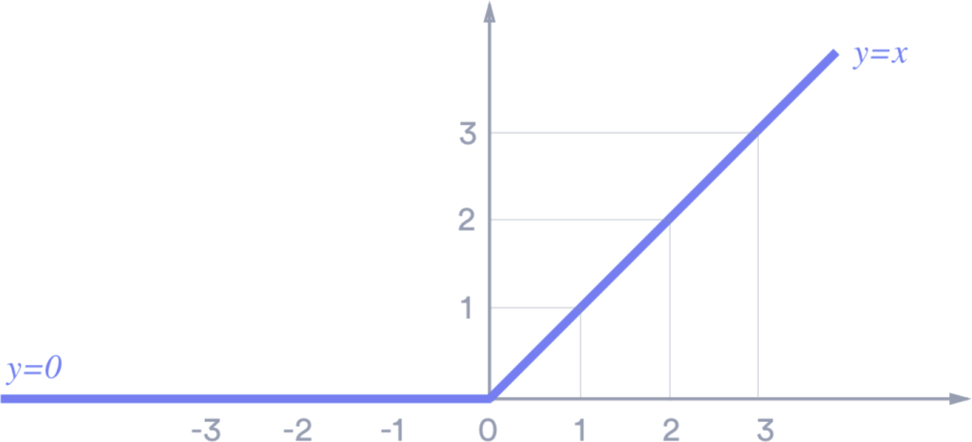

**Figure7.3:**ReLU

### Sigmoid:

It takes a real-valued number x and squashes it into a range between 0 and 1. Inparticular,largenegativeandpositiveinputsareplacedverycloseto0andunity,respectively.It is expressed as

f(x)=1/(1+e-x)

### 7.3.1.3 Softmax Activation:

The softmax function is also a type of sigmoid function but is handy when we aretryingtohandleclassificationproblems.Softmaxfunctionisoftendescribedasacombinationofmultiplesigmoids.Weknowthatsigmoidreturnsvaluesbetween0and1,which can be treated as probabilities of a data point belonging to a particular class. Thus,sigmoidis widely used for binary classification problems.

Thesoftmax function can be used for multiclass classification problems. Thisfunctionreturns the probability for a data point belonging to each individual class. Hereis the mathematical expression of the same-



Thisfunctionismainlyusedinmulti-classmodelswhereitreturnsprobabilitiesof each class, with the target class having the highest probability. It appears in almost allthe output layers of the DL architecture where they are used. The primary differencebetweenthesigmoidandsoftmaxAFisthatwhiletheformerisusedinbinaryclassification, the latter is used for multivariate classification.

Softmax function is described as a combination of multiple sigmoids. It calculatesthe relative probabilities. Similar to the sigmoid/logistic activation function, the Softmaxfunction returns the probability of each class. It is most commonly used as an activationfunction for the last layer of the neural network in the case of multi-class classification.

Uses: - Usually used when trying to handle multiple classes. The softmax functionwould squeeze the outputs for each class between 0 and 1 and would also divide by thesum of the outputs.

Output: - The softmax function is ideally used in the output layer of the classifierwhere we are actually trying to attain the probabilities to define the class of each input.

## DenseLayers:

In any neural network, a dense layer is a layer that is deeply connected with itspreceding layer which means the neurons of the layer are connected to every neuron of itsprecedinglayer.

The dense layer‘s neuron in a model receives output from every neuron of itspreceding layer, where neurons of the dense layer perform matrix-vector multiplication.Matrix vector multiplication is a procedure where the row vector of the output from thepreceding layers is equal to the columnvector of the dense layer. The general rule ofmatrix-vector multiplication is that the row vector must have as many columns like thecolumnvector.

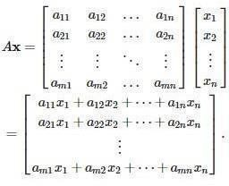

### Keras Dense Layer Hyper parameters:

As we can see a set of hyper parameters being used in Dense Layers, let us try tounderstand their significance.

**Units:** Units are one of the most basic and necessary parameters of the Kerasdenselayerwhichdefinesthesizeoftheoutputfromthedenselayer.Itmustbeapositiveintegersince it representsthe dimensionality ofthe output vector.

**Activation:** In neural networks, the activation function is a function that is usedfor the transformation of the input values of neurons. Basically, it introduces the non-linearityintothenetworksofneuralnetworkssothatthenetworkscanlearntherelationship between the input and output values. If in this Keras layer no activation isdefined it will consider the linear activation function.

## Dropout:

Dropoutisaregularizationmethodwhere input and recurrent connections toLSTMunitsareprobabilisticallyexcludedfrom activation and weight updates whiletraininganetwork.Thishastheeffect of reducing overfitting and improving modelperformance. A single model can be used to simulate having a large number of differentnetwork architectures by randomly dropping out nodes during training. This is calleddropout and offers a very computationally cheap and remarkably effective regularizationmethod to reduce overfitting and improve generalization error in deep neural networksofall kinds. Dropout is implemented per-layer in a neuralnetwork.

It can be used with most types of layers, such as dense fully connected layers,convolutional layers, and recurrent layers such as the long short-term memory networklayer. Dropout may be implemented on any or all hidden layers in the network as well asthevisible orinput layer.It isnot usedon the outputlayer.

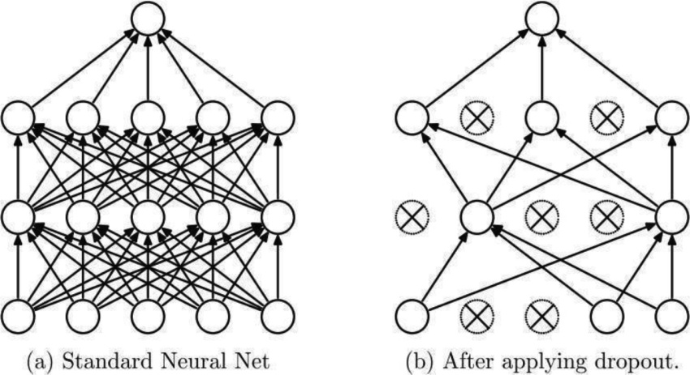

**Figure7.4:**Dropout

## Maxpooling2D

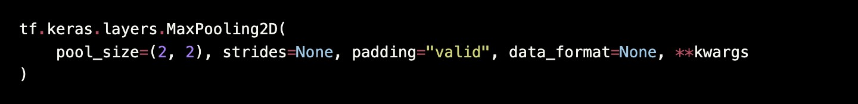

Max pooling operation for 2D spatial data.

Downsamples the input along its spatial dimensions (height and width) by takingthe maximum value over an input window (of size defined by pool_size) for each channelof the input. The window is shifted by strides along each dimension.

The resulting output, when using the "valid" padding option, has a spatial shape(number of rows or columns) of:

output_shape=math.floor((input_shape-pool_size)/strides)+1(wheninput_shape>= pool_size)

The resulting output shape when using the "same" padding option is:output_shape = math.floor((input_shape - 1) / strides) + 1

For example, for strides=(1, 1) and padding="valid":

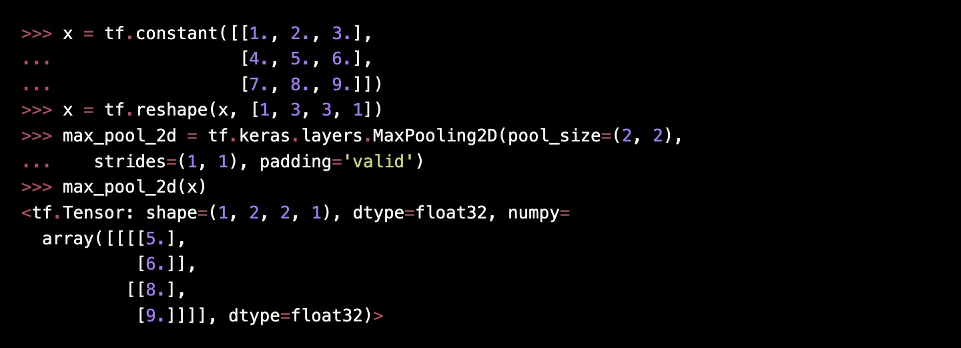

## BatchNormalizationLayer

Batch normalization applies a transformation that maintains the mean output closeto 0 and the output standard deviation close to 1.Importantly, batch normalization worksdifferently during training and during inference.During training (i.e. when using fit() orwhen calling the layer/model with the argument training=True), the layer normalizes itsoutputusingthemeanandstandarddeviationofthecurrentbatchofinputs.Thatistosay,foreachchannelbeingnormalized,thelayerreturnsgamma*(batch-mean(batch))/sqrt(var(batch) + epsilon) + beta, where: epsilon is small constant (configurable as part ofthe constructor arguments), gamma is a learned scaling factor (initialized as 1), which canbedisabledbypassingscale=Falseto the constructor, beta is a learned offset factor(initializedas0), whichcan bedisabledby passingcenter=False totheconstructor.

Duringinference(i.e.whenusingevaluate()orpredict()or when calling thelayer/model with the argument training=False (which is the default), the layer normalizesits output using a moving average of the mean and standard deviation of the batches it hasseenduring training. That is tosay, it returns

gamma * (batch - self.moving_mean) / sqrt(self.moving_var+epsilon) + beta.self.moving_meanandself.moving_vararenon-trainablevariablesthatare

updated each time the layer in called in training mode, as such:

moving_mean = moving_mean * momentum + mean(batch) * (1 - momentum)moving_var = moving_var * momentum + var(batch) * (1 - momentum)

Assuch,thelayerwillonlynormalizeitsinputs during inference after havingbeen trained on data that has similar statistics as the inference data.

Whensynchronized=Trueisset and if this layer is used within a tf.distributestrategy, there will be an allreduce call to aggregate batch statistics across all replicas atevery training step. Setting synchronization has no impact when the model is trainedwithoutspecifying any distribution strategy.

**BatchNormalization class**

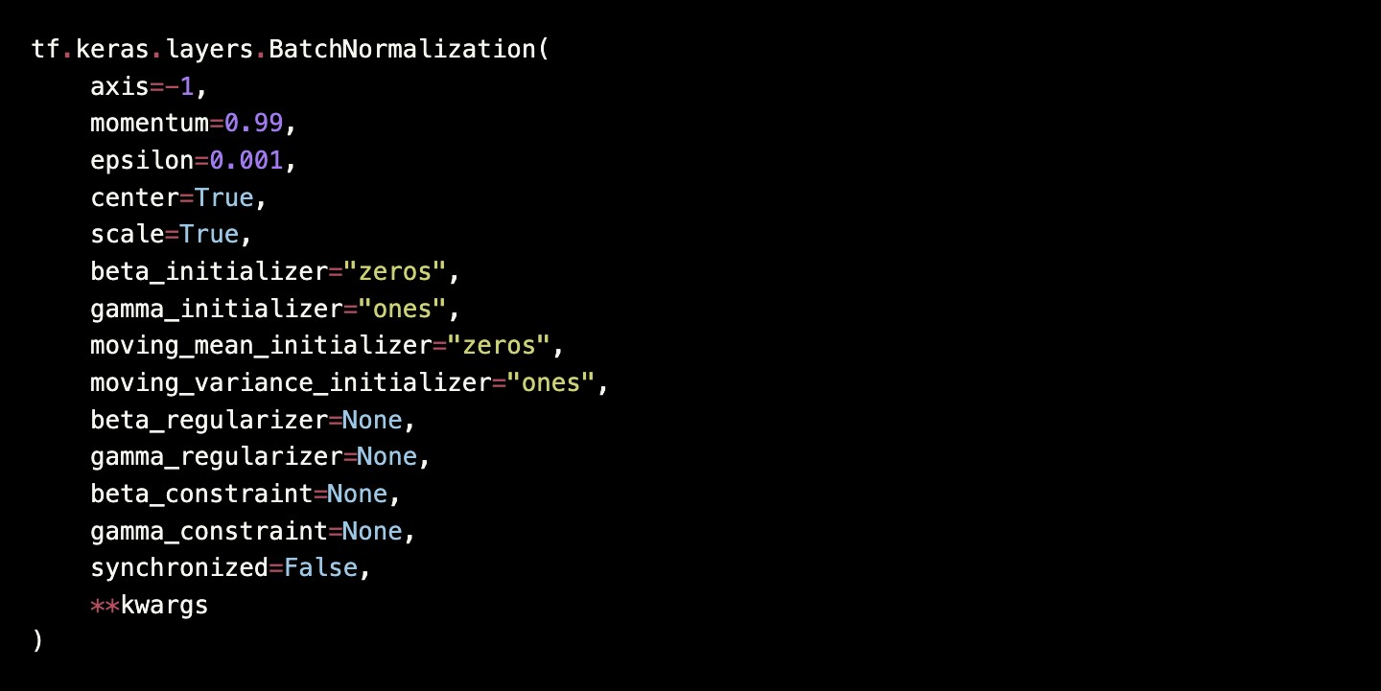

## Flattenlayer

Flattenstheinput. Doesnot affectthe batchsize.

Note:Ifinputsareshaped(batch,)withoutafeatureaxis,thenflatteningaddsanextra channel dimension and output shape is (batch, 1).

**Flatten class**



## PurposeofusingCNN:

ConvolutionalNeuralNetworks(CNNs)arecommonlyusedfordrowsinessdetection due to their ability to effectively analyze and extract features from visual data,such as images or video frames.

Here are some key reasons for using CNNs in drowsiness detection:

FeatureExtraction:CNNsarewell-suitedforautomaticallylearningrelevantanddiscriminative features from raw visual data. They utilize convolutional layers that applyfilters to capture local patterns and structures. These filters can identify important facialcuesassociatedwithdrowsiness,suchaseyeclosure,eyemovement,andfacial

expressions.

Spatial Hierarchies: CNNs can capture spatial hierarchies in visual data. The lower layersof a CNN detect basic features like edges and corners, while higher layers progressivelylearnmorecomplexandabstractfeatures.Thishierarchicalrepresentationisbeneficialfor drowsiness detection, as it allows the network to learn representations at differentlevelsofgranularity,frombasiceyemovementstomorecomplexpatternsassociatedwith drowsiness.

Robustness to Variations: CNNs are robust to variations in pose and facial expressions.They can handle different head orientations and lighting conditions, which is crucial forreal-world scenarios where people may have diverse appearances and environments. Thisrobustness enables the CNN to generalize well and detect drowsiness accurately acrossvarious conditions.

Efficiency: CNNs are computationally efficient for processing visual data. They exploitparameter sharing and convolutional operations, enabling them to process large amountsofimageorvideodatawithfewerparameterscompared to fully connected networks.ThisefficiencymakesCNNssuitableforreal-timeapplications,suchasmonitoringdrivers or operators in real-world settings.

In our case, CNN is effective for extracting features from visual data, othercomponents by capturing dynamic patterns over time to train the model in drowsinessdetectiontasksandpredictingtheexpected resultswhiletryingtomaintainaccuracy.

# CHAPTER 8IMPLEMENTATIONANDEXECUTION

## CNN:

Intheproject,ConvolutionalNeuralNetworks(CNNs)aretypicallyusedtoanalyzeandclassifyfacialfeaturesorimageframestodeterminethepresenceofdrowsiness. Here's an overview of how CNNs are used in drowsiness detection:

Data Preparation: The project begins by collecting or acquiring a dataset of images orvideo frames that contain facial information. These images can be captured using camerasor extracted from video recordings.

DataPreprocessing:Thecollectedimagesare preprocessed to ensure uniformity andenhancethequalityofthedata.Preprocessingstepsinvolvesresizingimagestoaconsistentresolution,normalizingpixelvalues,andperformingany necessary imageenhancement techniques.

Training Data Preparation: The dataset is divided into training and validation sets. Thetraining set is used to teach the CNN to recognize patterns and features associated withdrowsiness. It is essential that the dataset is well-balanced, representing both drowsy andnon-drowsy instances, to avoid bias in the model's learning process.

CNNArchitectureDesign:ACNNarchitectureisdesigned,typicallyconsistingofmultiple convolutional layers followed by pooling layers and fully connected layers. Thenumber and configuration of these layers depend on the specific project requirements andthe complexity of the drowsiness detection task.

Training the CNN: The training process involves feeding the preprocessed images fromthe training set into the CNN. The CNN learns to automatically extract relevant featuresfrom the images through forward propagation and adjusts its internal parameters duringbackpropagationtominimizethedifference between predicted and actual drowsinesslabels. This process is repeated for multiple iterations or epochs until the CNN convergesand achieves satisfactory performance on the validation set.

Testing and Deployment: Once the CNN is trained and evaluated, it can be tested anddeployed.Duringtestingordeployment,theCNNtakesinunseenimagesorvideoframes

and makes predictions on the presence of drowsiness. The output is a binary classificationvalue (drowsy [1] or not drowsy[0]).

## GUI:

A frontend web framework is provided which is developed in Tkinter. The usercan start the system that detects the drowsy condition and alerts the user. The interface isuser friendly and designed in a way that it is easy to access in a driving condition. Thisinterface helps the user to interact with the system seamlessly and helps to reduce theattention diversion of the driver while he is driving the vehicle.

TheinterfaceisbuiltusingPythonopensourcetkinterlibrarymodule.Thislibraryprovidesinbuiltfunctionalitiesforinvokingthefunctionsdefinedinsidethesource code.

**Figure8.1:**GUI

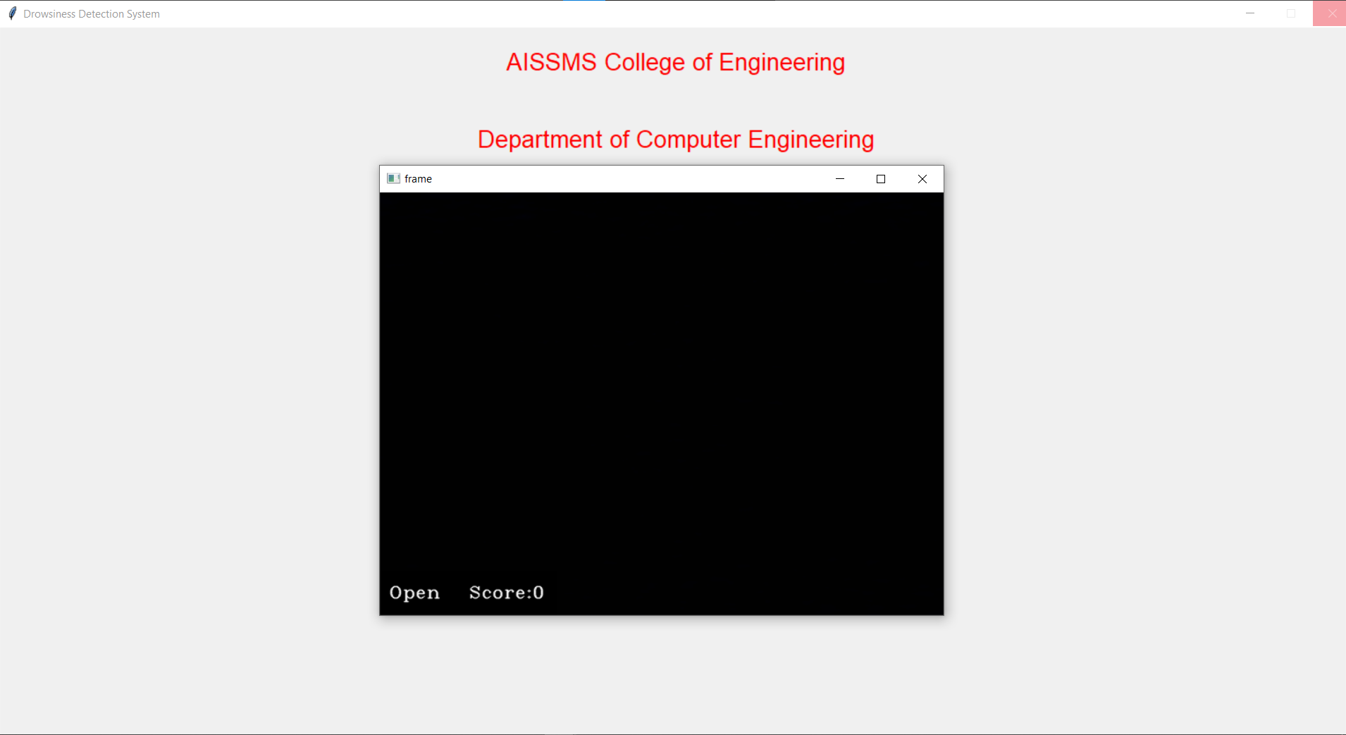

**Figure8.2:**OperationalWindow

## Input:

With a webcam, we will take images as input. So to access the webcam, we madean infinite loop that will capture each frame. We use the method provided by OpenCV,cv2.VideoCapture(0) to access the camera and set the capture object (cap). cap.read() willread each frame and we store the image in a frame variable.

**Figure8.3:**InputVideoScreen1

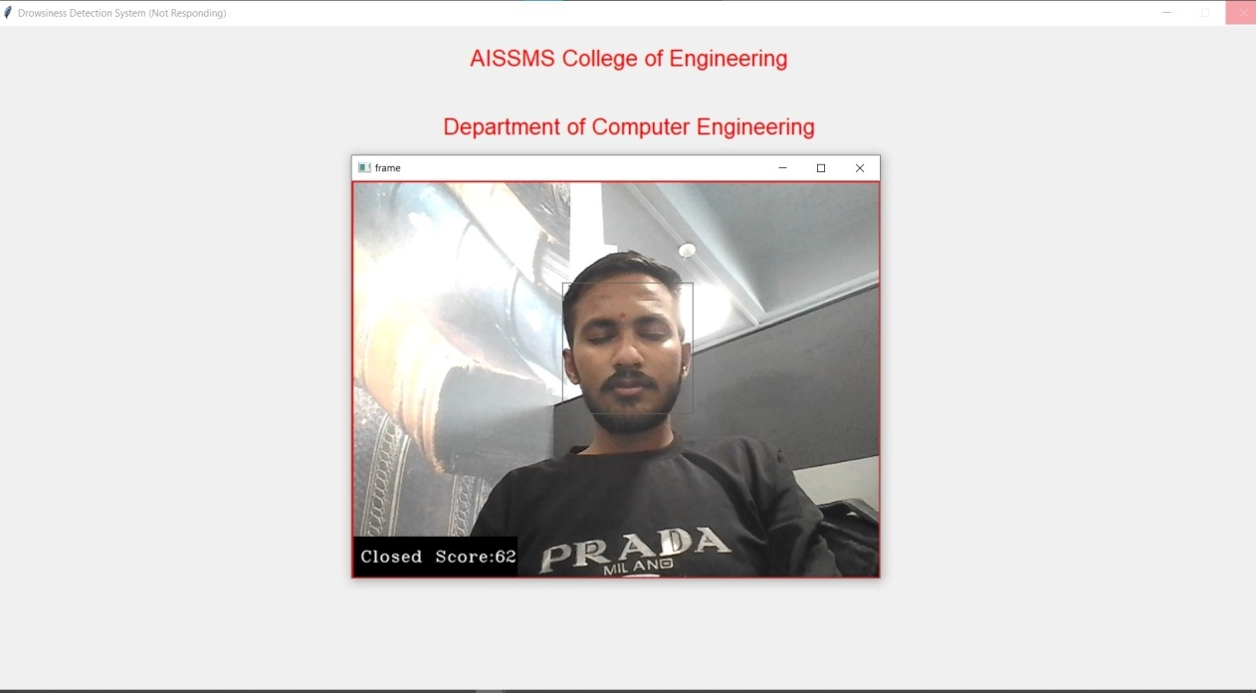

**Figure8.4:**InputVideoScreen2

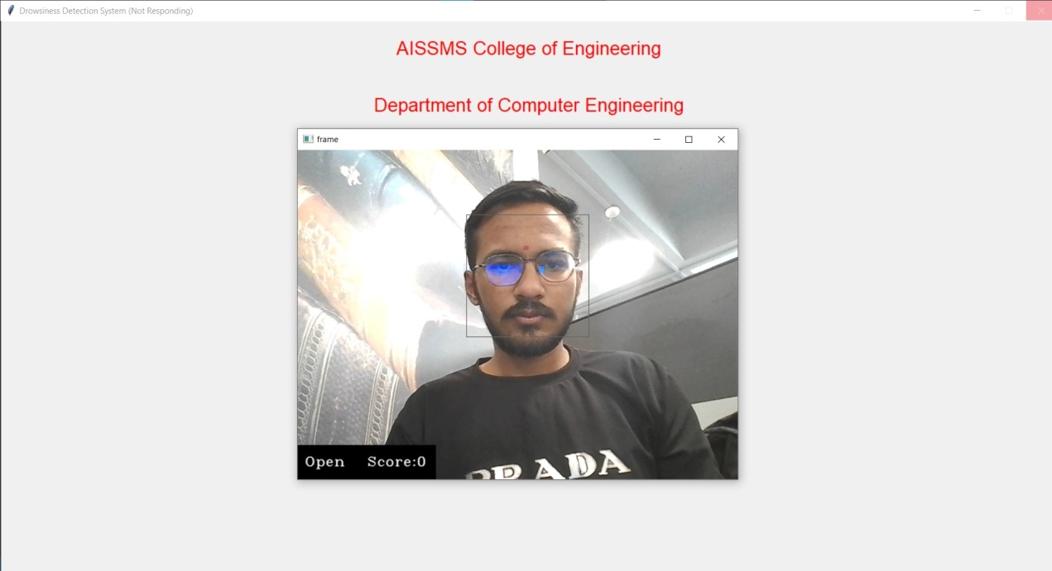

**Figure8.5:**InputVideoScreen3

## ExpectedOutcomes:

The expected outcomes of this project should be aligned with the objectives of theproject. The output given by the system is in audio visual format. The score is displayedwhereyou can seethe extent to whichthe driver is drowsy.

**Figure8.6:**OutputVideoScreen1

**Figure8.7:**OutputVideoScreen2

## ProjectEstimate:

Waterfallmodelisbeingusedfortheprojectestimation.Itdepictsthestepwiseexecution of the entire project.

### Reconciled Estimates Cost Estimate:

Not Applicable.

### TimeEstimate:

The estimated time for the project was around nine months.Theseestimatesincludeallthestepsincludedintheprojectplan.

### ProjectResources:

Python Programming Languages, Python Open source libraries, IDE, CPU >=2GHzFrequency, Webcamera.

## RiskManagement:

The drowsiness detection process is dependent on multiple factors based on inputimageortrainingaccuracyanddataset.The model must be trained on accurate andconsiderable data that should cover multiple aspects of the realistic conditions in whichthe driver can be present when facing the drowsy condition.

### Risk Identification

The various risks that are identified are:

* + - * Processing power for processing live image feed in a real time scenario.
      * Considerable training data is used when a model is being trained.
      * Highqualityvideocameraisrequiredtoprovideclearimagesofthedriver.
      * Toreducetheoverfittingconditionwhiletrainingthemodel

## ProjectSchedule:

### ProjectTaskSet:

Project tasks in Project are:

1. Project topic selection
2. Literature survey and study of papers
3. Requirement gathering phase
4. Installing required libraries and softwares in the system.
5. Coding and implementation
6. Model training phase
7. Unit and Integration testing
8. System testing
9. Modifications and documentation

## TeamOrganization:

* + 1. **TeamOrganization**

Varioustasksaredistributedamongfourteammembers.

Distribution of tasks is done based on the skill sets and considering the balanceddistribution of the workload among the team members.

|  |  |  |
| --- | --- | --- |
|  |  |  |
|  |  |  |
|  |  |  |
|  |  |  |
|  |  |  |

### Management Reporting and Communication

* + - TomaintainalogbookandkeepdetailofalltheinformationaboutthemeetingwiththeInternal Project Guide.
    - Tocompletesynopsisandreviewwithinthegiventime
    - Weeklyupdateoftheassignmentsgivenbytheexternalguide.
    - Teammeetingfrequentlyaspossibletodiscusstheprogressoftheproject.
    - Meeting with the internal guide and external guides as frequently as possible and loggingof the work by every time.

# CHAPTER 9RESULTS

### 9.1 ScreenshotsofOutput

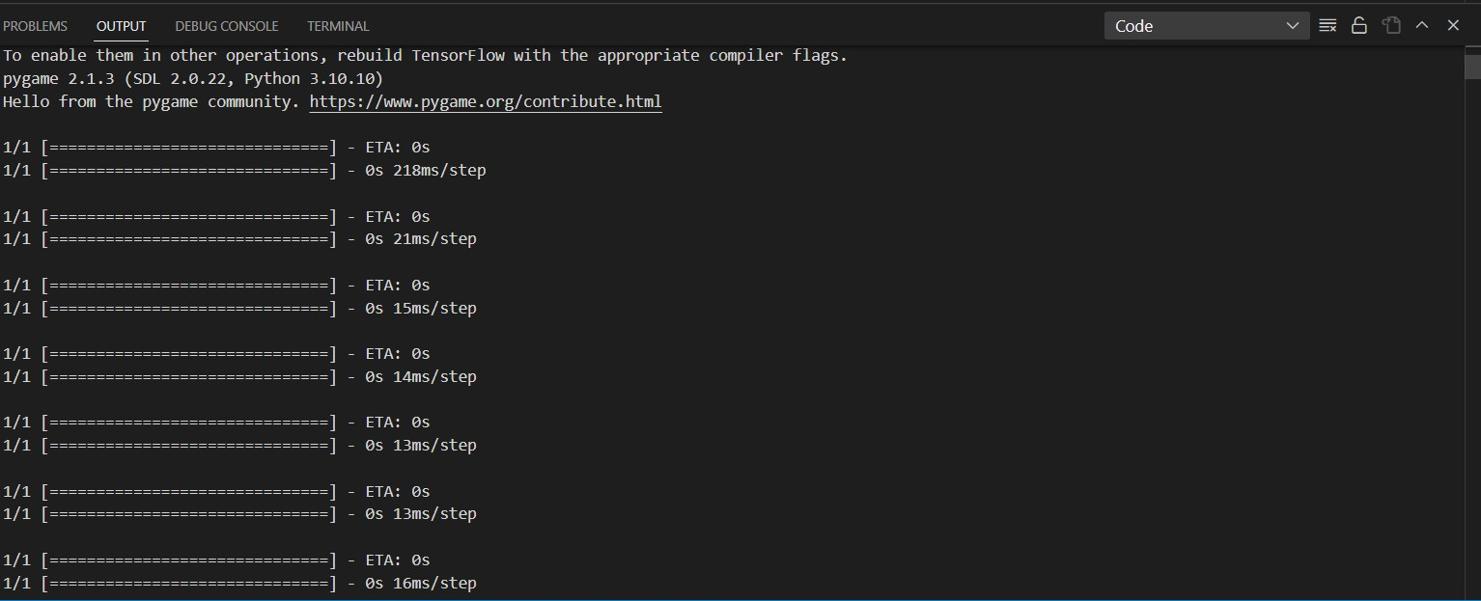

**Figure9.1:**TerminalOutputScreen1

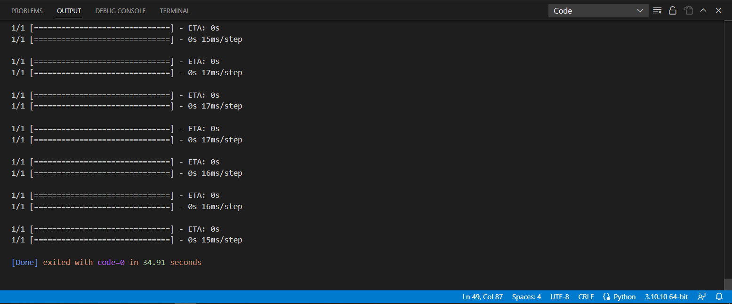

**Figure9.2:**TerminalOutputScreen2

* 1. **Conclusion**

Inconclusion,thecreationofaDrowsinessdetectionsystemusingmachinelearning has enormous potential for improving traffic safety and reducing the hazardsrelated to driver weariness. Such a system may efficiently monitor driver behavior, spotindicatorsofintoxication,andsendouttimelyalertstoavertpotentialaccidents byutilizing cutting-edge algorithms and data processing techniques. In real-time data, suchaseyemovement,facialexpressions,andvehicledynamics,this system shows howmachinelearningmaybeusedtoidentifypatternsandanomalies.Thesystemcanaccurately detect the driver's level of awareness and estimate the likelihood of drowsinessby using machine learning models. The stimulation of an alert, vibrating the steeringwheel, or sending notifications to the driver is only one example of how this proactivestrategy permits early response.

## FutureScopeoftheProject

* Enhanced Accuracy: Continued research can focus on improving the accuracy ofthedrowsinessdetectionsystembyrefiningmachinelearningalgorithmsandincorporating additional data sources. This could involve exploring new features such asheartratemonitoring,brainwaveanalysis,orevenenvironmentalfactorslikecabintemperature and humidity to provide a more comprehensive assessment of driver fatigue.
* Multi-modal Sensing: Expanding the range of sensors used in the system can leadtoamorerobustandaccuratedetectionmechanism.Integratingadditionalsensingmodalities such as infrared cameras for eye tracking, steering wheel sensors for handmovements, or even microphone arrays for analyzing speech patterns can provide a morecomprehensive understanding of the driver's state.
* Real-time Intervention: Expanding the capabilities of the system to intervene inreal-time can be a valuable future direction. For example, integrating the system withsmart vehicle control mechanisms, such as adaptive cruise control or lane-keeping assist,can enable automated adjustments to maintain safe driving conditions when drowsiness isdetected.
* Integration with Autonomous Vehicles: As autonomous vehicles become moreprevalent,integratingdrowsinessdetectionsystemswithautonomousdrivingtechnologies can enhance overall safety. By monitoring the drowsiness levels of bothhumandriversandautonomoussystems,the combined system can ensure smooth andsafe transitions between manual and autonomous driving modes.
* Mobile Applications and Wearable Devices: Expanding the reach of drowsinessdetectionbeyondvehiclesto other contexts, such as mobile applications or wearabledevices, can have significant benefits. These applications can help individuals monitortheir alertness levels during activities like working, studying, or operating machinery,reducingthe riskof accidents andimproving overall productivity.

## Advantages

* Improved Road Safety: Improving road safety is one of the main benefits of adrowsiness detection project. The device can aid in preventing accidents brought on bydriver weariness by correctly identifying drowsy drivers.
* Accidentavoidance:Drunkdrivingisamajorcontributortomanytrafficaccidents. Real-time drowsiness detection can allow for prompt alerts or interventions,like an alarm or visual cues, to stop accidents from happening.
* Drowsiness detection devices can serve as an early warning system for driverswhomaynotbeconsciousoftheirowndrowsiness.Driverscantaketherequiredprecautions to avert potential accidents by receiving timely alerts.
* Driver Comfort: Drowsiness detection systems can improve driver comfort byidentifyingwearinessandsendingoutthepropersuggestionsoralerts,suchasrecommending rest stops or reminding drivers to take breaks.
* Data Gathering and Analysis: Drowsiness detection studies can provide usefulinformation on patterns of fatigued driving behavior. This information can be analyzed tolearnmoreaboutsleep-relatedproblems,advancingstudyandthecreationofpreventative interventions.

## Disadvantages

* PrivacyIssues:Drowsinessdetectiontechnologiesfrequently capture personaldata and observe driving behavior, which raises privacy issues. Drivers can feel uneasyabout being constantly watched and disclosing private information.
* CostandUsability:Installingdrowsinessdetectionsystemscanbepricey,particularly if they are to be widely used in vehicles. The cost of hardware, softwaredevelopment, and upkeep may prevent all drivers from using such systems.
* False Alarms: Systems for detecting drowsiness may produce false alarms thatcausepointlessalertsorinterventions.Thismayaggravatethedriverandcausedistractions,which will negatively affect the drivingexperience as a whole.
* Technical restrictions: Different sensors and algorithms are used in drowsinessdetection technologies, which may have some restrictions. The performance of the systemcan be impacted by environmental variables, sensor accuracy, and algorithm efficacy,which can produce unreliable results.

## Applications

Applications for the Drowsiness detection project are numerous, especially in the areasoftransportation anddriver safety. Hereare a fewtypical examples:

* TransportingPeople:Drowsinessdetectionsystemscanbeintegratedbydelivery,taxi,andride-sharingservicestoprotectthewell-beingofits drivers andcustomers. When a motorist is too tired to operate a car safely, real-time alerts mightencourage them to stop driving or take the appropriate pauses.
* Using Public Transit: To improve passenger safety, drowsiness detection can beapplied in public transport systems like trains and trams. The driver and the appropriateauthoritiescanbeinformedifthesystemnoticesadrowsyoperatortohelpavoidaccidents.
* Transportation Services: To protect the safety of its drivers and passengers, taxi,ride-sharing, and delivery services can integrate drowsiness detection systems. When amotorist is too tired to operate a car safely, real-time alerts might encourage them to stopdriving or take the appropriate pauses.
* PublicTransport:To improve passenger safety, drowsiness detection can beappliedinsystemsliketrains and trams. The driver and the appropriate authorities canbe informed if the system notices a drowsy operator to help avoid accidents.
* ResearchandSleepStudies:Bygathering information on driving habits andexhaustion patterns, drowsiness detection projects can contribute to research and sleepstudies.Understandingsleep-relatedproblems,creatingpreventativestrategies,andenhancing sleep health can all be aided by this data.

# CHAPTER 15REFERENCES

1. DriverDrowsinessDetectionusingMachineLearningwithVisualBehaviour

Shivanand Phulari1, Pranita Dalvi2, Pooja Girme3, Nikita Bhosale4, Payal Deshmukh5 , MohiniPansare6

InternationalJournalforResearchinAppliedScience&EngineeringTechnology(IJRASET)

1. Real-time Driver Drowsiness Detection for Android Application Using Deep Neural NetworksTechniques,RatebJabbara*,KhalifaAl-Khalifa,b,MohamedKharbechea,WaelAlhajyaseena,MohsenJafaric,ShanJiangc,The9thInternationalConferenceonAmbientSystems,Networks,andTechnologies(ANT2018)
2. Real-TimeDriverDrowsinessDetectionusingComputerVision,MahekJain,BhavyaBhagerathi, Sowmyarani C N,International Journal of Engineering and Advanced Technology(IJEAT)
3. DriverFatigueDetectionSystem,E.Rogado,J.L.García,R.Barea,L.M.Bergasa,MemberIEEEandE.López,InternationalConferenceonRoboticsandBiomimeticsBangkok,Thailand
4. AReal-timeDrivingDrowsinessDetectionAlgorithmWithIndividualDifferencesConsideration, FENG YOU 1 , XIAOLONG LI 1, YUNBO GONG 1, HAIWEI WANG 2, ANDHONGYILI3,4,IEEEAccess
5. Driver Drowsiness Detection Using Machine Learning, Prof. Swati Gade1, Kshitija Kamble2,Aishwarya Sheth3, Sakshi Patil4, Siddhi Potdar5, international Journal for Research in AppliedScience&EngineeringTechnology(IJRASET)
6. Real Time Driver Drowsiness Detection Using a Logistic-Regression-Based Machine LearningAlgorithm, Mohsen Babaeian, Nitish Bhardwaj, Bianca Esquivel, and Mohammad Mozumdar,2016IEEEGreenEnergyandSystemsConference(IGSEC)
7. DriverFatigueDetectionSystem,YogeshChellappa,NarendraNathJoshi, and VaishnaviBharadwaj,IEEEInternationalConferenceSignalandImageProcessing
8. MachineLearningandGradientStatisticsBasedReal-TimeDriverDrowsinessDetection,Cyun-YiLin*,PaulChang#,AlanWang#,andChih-PengFan*,2018 IEEE InternationalConferenceonConsumerElectronics-Taiwan(ICCE-TW)
9. A Study on Feature Extraction Methods Used to Estimate a Driver’s Level of Drowsiness,Kyong He Lee, Whui Kim, Hyun Kyun Choi, Byung Tae Jang, International Conference onAdvancedCommunicationTechnology(ICACT)
10. Real-Time Driver Drowsiness Detection System Using Eye Aspect Ratio and Eye ClosureRatio,SukritMehta,SharadDadhich,Sahil Gumber, Arpita Jadhav Bhatt, 2019 SUSCOM.HostedbyElsevierSSRN.
11. AMultimodalBiometricSystemforPersonalIdentificationBasedonDeepLearningApproaches, Alaa S. Al-Waisy, Rami Qahwaji, Stanley Ipson, Shumoos Al-FahdawiSeventhInternationalConferenceonEmergingSecurityTechnologies2018(EST)

|  |  |  |  |  |  |  |  |
| --- | --- | --- | --- | --- | --- | --- | --- |
| **ReportDocumentation** | | | | | | | |
| ReportCode:CS-BE-Project2023-2024 | | | | | ReportNumber:ID31 | | |
| ReportTitle:DrowsinessDetectionandAlertSystemusingMachineLearningApproach | | | | | | | |
| **Address(Details):**  **AISSMSCollegeofEngineering,PunePin–411001,M.S.INDIA.** | | | | | | | |
| **Author1** | | **Author2** | | **Author3** | | **Author4** | |
| **Year:** 2022-2023  **Branch:**ComputerEngineering | | | | | | | |
| ***KeyWords*:**Drowsiness,Distraction,Eyedetection,EyeTracking,FaceDetection,Perclos | | | | | | | |
| TypeofReport:FINAL | ReportCheckedBy:  **Prof.** | | ReportChecked | | Guides Complete Name:  **Prof.** | | TotalCopies |

**Abstract:**

Many of the accidents occur due to drowsiness of drivers. It is one of the critical causes ofroadways accidents now-a-days. Latest statistics say that many of the accidents were caused because ofdrowsiness of drivers. Vehicle accidents due to drowsiness in drivers are causing deathto thousands oflives. More than 30% of accidents occur due to drowsiness. For the prevention of this, a system is requiredwhich detects drowsiness and alerts the driver which saves the life. In this project, we present a scheme fordriver drowsiness detection based on visual information and Machine Learning. In this, the driver iscontinuously monitored through a webcam. This system is used to locate, track, and analyze both thedriversfaceandeyes,ascientificallysupportedmeasureofdrowsinessassociatedwithsloweyeclosure.The model extracts the driver's face and predicts the blinking of the eye from the eye region. If the blinkingrate is high then the system alerts the driver with a sound.

ProjectWorkBook FourthYearComputerEngineering,SPPU,Pune